CYART TECHNOLOGY

Security Assessment Findings Report

Date: May 8th, 2026
Project: Security Findings
Version 1.0

Table of Content
Introduction 3
Objective of Assessment 3
Scope 4
Environment Setup 5
Reconnaissance & Enumeration 6
Vulnerability Assessment 16
Exploitation 27
Risk assessment 31
Findings- Documentation 31
Recommendations 42
Conclusion 43
Challenges 43

Introduction
Vulnerability Assessment and Penetration Testing (VAPT) is a security assessment process used to identify, analyze, and validate security weaknesses within systems, networks, and applications. The objective of VAPT is to evaluate the security posture of an environment by simulating real-world attack methodologies in a controlled and authorized manner.
This assessment was conducted within a virtualized lab environment using Kali Linux as the attacker machine and Metasploitable2 as the vulnerable target machine. The assessment focused on identifying exposed services, insecure configurations, outdated software, and exploitable vulnerabilities using open-source security tools and standardized testing methodologies.
The testing activities performed during this assessment included:
- network discovery,
- service enumeration,
- vulnerability assessment,
- exploitation validation,
- risk assessment,
- and remediation planning.
The assessment methodology was aligned with industry-recognized security practices, including concepts derived from OWASP testing methodologies, NIST SP 800-115, and ISO 27001-based risk assessment principles.

Objective of Assessment
The primary objective of this assessment was to perform a controlled Vulnerability Assessment and Penetration Testing (VAPT) exercise against the Metasploitable2 environment to identify security weaknesses and validate exploitation risks using open-source security tools.
The assessment aimed to:
- identify open ports and exposed services,
- analyze insecure configurations,
- detect outdated software components,
- validate exploitable vulnerabilities,
- perform qualitative risk assessment,
- and recommend mitigation strategies to improve the security posture of the environment.
The assessment additionally provided practical exposure to cybersecurity tools, vulnerability management concepts, and security reporting methodologies commonly used during real-world VAPT engagements.

Scope
The assessment was conducted on the Metasploitable vulnerable virtual machine hosted in Oracle VirtualBox. Kali Linux was used as the attacker machine for scanning, enumeration, vulnerability assessment, and basic penetration testing activities.

Environment Setup
Platform – VirtualBox
Attacker – Kali Linux
IP address of Kali Linux – 192.168.56.101

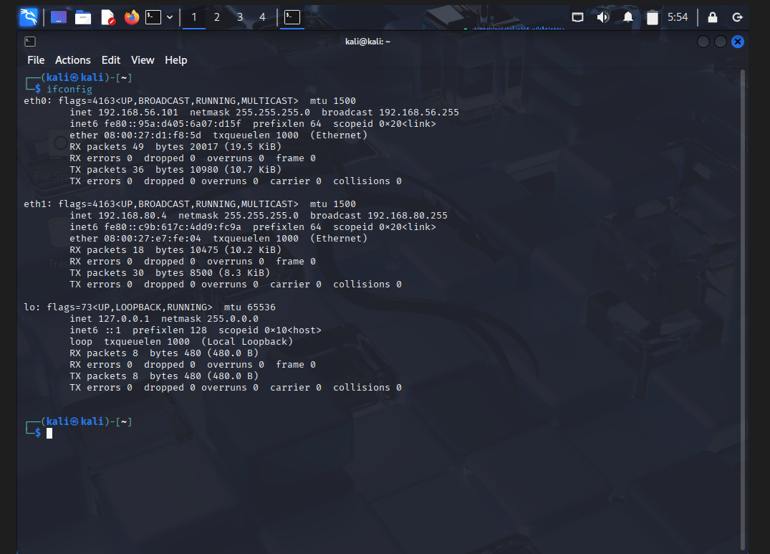

Target – Metasploitable2
IP address of Metasploitable2 - 192.168.56.102/24

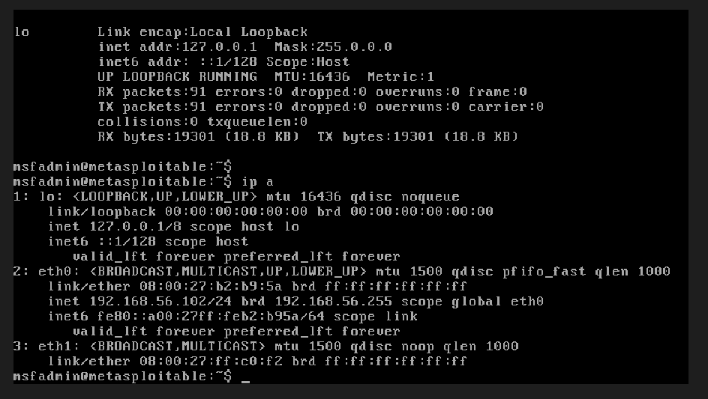

Reconnaissance & Enumeration
The goal is:
Gather as much information as possible about the target system.
Before exploitation, a pentester needs to know:
- Which services exist
- Which ports are open
- Which software is running
- What attack surface is exposed

The services with their versions running on the target
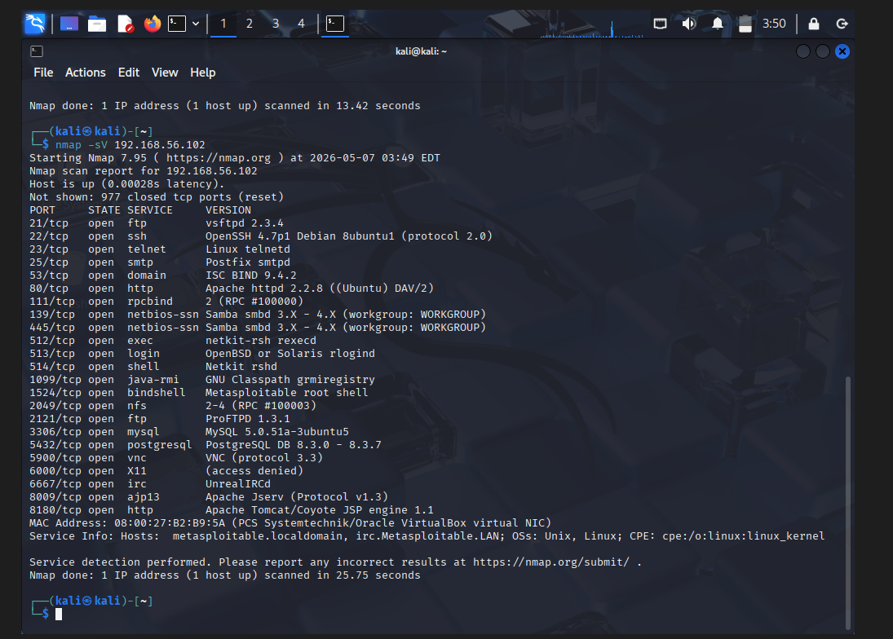

Port | Service | Security Relevance
21 | FTP | Weak authentication risk
22 | SSH | Remote administration
23 | Telnet | Insecure plaintext protocol
80 | HTTP | Web application attack surface
139/445 | SMB | File-sharing vulnerabilities
3306 | MySQL | Database exposure
5900 | VNC | Remote desktop exposure
8180 | HTTP service | Possible Tomcat/admin panel

On aggressive scan

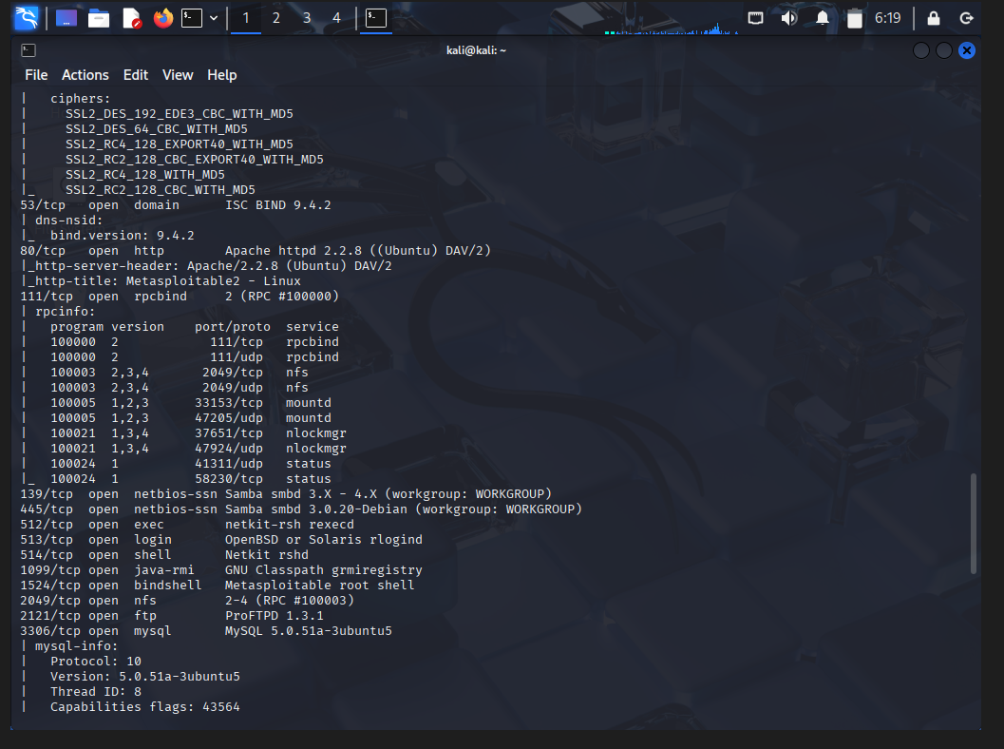
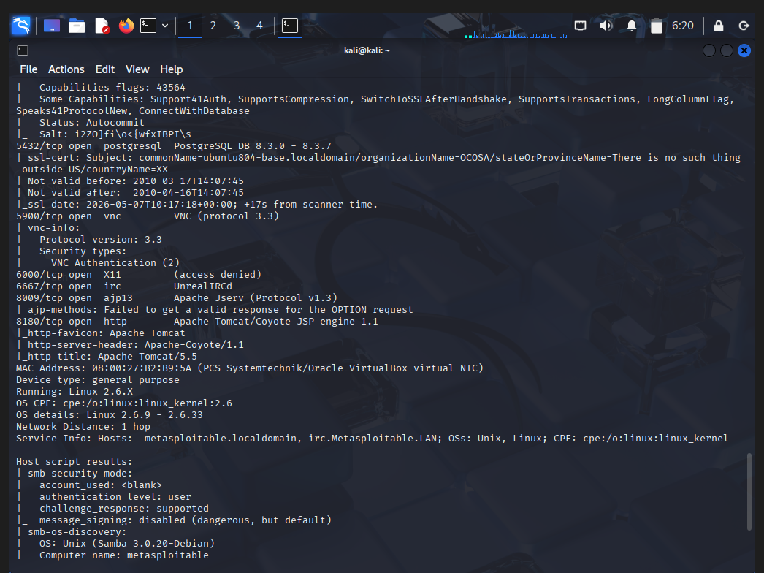
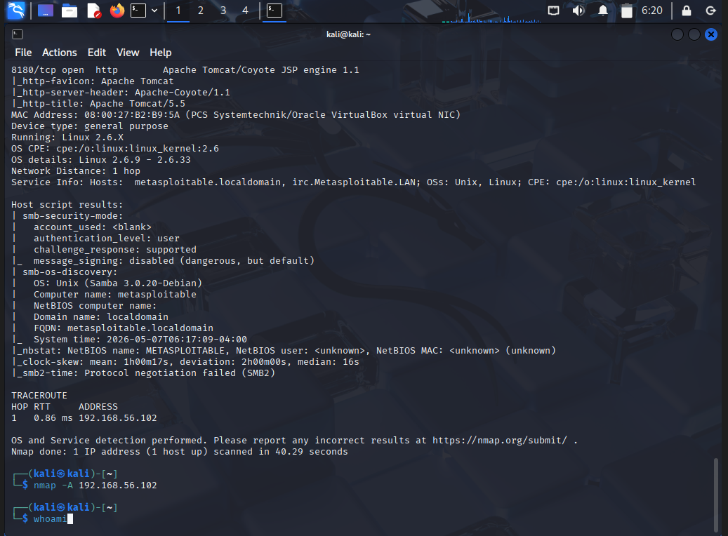
OS details: Linux 2.6.9 - 2.6.33

- Host Discovery
The scan successfully confirmed that the target machine was active and reachable within the virtual lab environment. Nmap detected that the host responded to network requests, which verified that communication between the Kali Linux attacker machine and the Metasploitable target machine was functioning correctly. The low latency observed during the scan indicated that both systems were connected locally within the same VirtualBox host-only network environment. This stage was important because successful host discovery validates network connectivity before deeper enumeration and vulnerability analysis can begin.

- Operating System Detection
Nmap successfully identified the target operating system as a Linux-based machine running a Linux 2.6.x kernel. OS fingerprinting techniques were used to analyze how the target system esponded to specially crafted packets. The scan further narrowed the kernel range to Linux 2.6.9–2.6.33, indicating that the system was running an older version of the Linux kernel. Older operating systems are commonly found in intentionally vulnerable lab environments such as Metasploitable because they contain outdated software and weaker security protections.

Security Impact
Outdated operating systems significantly increase the risk of system compromise because they may contain publicly known vulnerabilities that have already been patched in newer versions. Older Linux kernels may be vulnerable to privilege escalation attacks, denial-of-service conditions, memory corruption issues, and local exploitation techniques. Attackers often target outdated systems because exploit code and vulnerability documentation are widely available online. The detection of an obsolete Linux kernel during enumeration indicates that the target system may lack modern security controls and may be susceptible to multiple exploitation techniques during penetration testing activities.

- FTP Service Analysis
Port 21 on the target machine was found to be open and actively running the File Transfer Protocol (FTP) service. The scan identified the FTP server software as vsftpd 2.3.4, which is an older version of the Very Secure FTP Daemon commonly used on Linux systems for file transfer operations. During enumeration, the server was also found to allow anonymous FTP login, meaning users could potentially access the FTP service without valid authentication credentials. Additionally, the communication method used by FTP was identified as plaintext communication, indicating that data transmitted between the client and server is not encrypted. This means usernames, passwords, and transferred files could potentially be intercepted by attackers monitoring the network traffic.

Security Impact
The presence of an outdated FTP service significantly increases the attack surface of the target machine. Since FTP does not provide encryption by default, attackers performing packet sniffing within the network may capture sensitive authentication credentials and transferred data. The anonymous login configuration further weakens security because unauthorized users may gain access to shared directories or sensitive files without needing legitimate credentials. The vsftpd 2.3.4 is historically associated with a known backdoor vulnerability that has been publicly documented in cybersecurity research and exploit databases.
Attackers may attempt to exploit this weakness to gain unauthorized access or remote command execution on the system. From a security assessment perspective, this service represents a high-risk finding because it combines insecure communication, weak access control, and outdated software vulnerabilities within a single exposed service.

- SSH Service Analysis
Port 22 was identified as open and running the Secure Shell (SSH) service. The scan detected the service version as OpenSSH 4.7p1, which is an older implementation of the SSH protocol commonly used for secure remote administration of Linux systems. SSH is designed to provide encrypted communication between systems and is widely used by administrators to remotely manage servers and infrastructure. The presence of SSH on the target machine indicates that remote administrative access is enabled.

Security Impact
Although SSH is considered more secure than legacy remote access protocols such as Telnet, outdated SSH implementations may still contain vulnerabilities related to weak cryptographic algorithms, authentication bypass issues, or insecure default configurations. Attackers frequently target exposed SSH services using brute-force attacks, credential stuffing, or exploitation of known vulnerabilities. Older versions of OpenSSH may also support deprecated encryption methods that no longer meet modern security standards. The exposure of SSH services on publicly accessible systems increases the risk of unauthorized administrative access if proper hardening and authentication controls are not implemented.

- Telnet Service Analysis
Port 23 on the target machine was found to be running the Telnet service. Telnet is an older remote access protocol historically used for command-line administration of systems over a network. Unlike modern secure protocols, Telnet does not implement encryption for transmitted data. The scan identified the service as Linux telnetd, confirming that remote login functionality was enabled through an insecure communication protocol.

Security Impact
The presence of Telnet represents a serious security weakness because all communication, including usernames and passwords, is transmitted in plaintext across the network. Attackers performing network sniffing or Man-in-the-Middle attacks can easily capture authentication credentials and session information. Due to the lack of encryption and modern security protections, Telnet has largely been replaced by SSH in secure environments.

- SMTP Service Analysis
Port 25 was discovered to be running a Simple Mail Transfer Protocol (SMTP) service identified as Postfix smtpd. SMTP services are responsible for handling email transmission between systems and mail servers. During enumeration, Nmap detected SSL certificate information and protocol support details associated with the mail service. The presence of SMTP indicates that the target system is configured to support email-related functionality.

Security Impact
Improperly configured SMTP services may introduce multiple security risks, including open mail relay attacks, email spoofing, spam abuse, and information disclosure. Older mail server implementations may also support weak SSL/TLS configurations and deprecated encryption algorithms that can be exploited by attackers. Exposed SMTP services may allow attackers to gather internal system information, enumerate valid users, or abuse the mail infrastructure for malicious purposes. Misconfigured email services are commonly leveraged during phishing campaigns and social engineering attacks.
- DNS Service Analysis
Port 53 was identified as open and running the Domain Name System (DNS) service using ISC BIND 9.4.2. DNS services are responsible for translating domain names into IP addresses and are critical components of network communication infrastructure. The version information obtained during enumeration indicated that the DNS software was outdated and potentially vulnerable to publicly known security issues.

Security Impact
Outdated DNS services may expose systems to attacks such as cache poisoning, denial-of-service attacks, and information leakage. Attackers often target DNS servers because they play a central role in directing network traffic and communication. Vulnerable DNS configurations may also allow unauthorized zone transfers, enabling attackers to gather detailed internal network information.

- SMB Service Analysis
Ports 139 and 445 were found open and running Samba SMB services. Server Message Block (SMB) is commonly used for file sharing, printer sharing, and network communication within Windows and Linux environments. Nmap further identified that SMB message signing was disabled on the target machine. Additional enumeration revealed details about the operating system, workgroup, and NetBIOS information associated with the SMB service.

Security Impact
SMB services are historically associated with several major cyberattacks and ransomware campaigns. Weak or outdated SMB implementations may allow attackers to perform remote code execution, unauthorized file access, lateral movement, and credential theft. Disabled SMB message signing increases the risk of Man-in-the-Middle attacks because attackers may intercept or modify SMB traffic without integrity verification. The exposure of SMB services combined with insecure configurations represents a critical security finding due to the high number of publicly available SMB exploitation techniques.

- Database Service Analysis
Ports 3306 and 5432 were identified as open and running MySQL and PostgreSQL database services respectively. The scan detected MySQL 5.0.51a and PostgreSQL 8.3.x versions on the target machine. Database services are responsible for storing and managing application and system data. Their exposure on the network indicates that remote database access is enabled.

Security Impact
Exposed database services significantly increase the risk of unauthorized data access, credential theft, and database compromise. Older database versions may contain vulnerabilities that allow attackers to bypass authentication or execute malicious queries. Weak passwords or default credentials further increase the likelihood of successful attacks. Attackers frequently target exposed databases to steal sensitive information, manipulate stored data, or gain deeper access into systems. The presence of outdated and externally accessible database services represents a high-risk finding within the assessment.

- VNC Service Analysis
Port 5900 was identified as running a Virtual Network Computing (VNC) remote desktop service. VNC allows remote graphical access and administration of systems over a network. The scan detected VNC protocol version 3.3 and identified that authentication was enabled.

Security Impact
Older VNC implementations may use weak encryption or insecure authentication mechanisms, making them susceptible to brute-force attacks and credential compromise. Remote desktop services are highly attractive targets because successful exploitation may provide attackers with direct graphical control over the target system. Weak passwords or insecure configurations further increase the likelihood of unauthorized access. Exposed VNC services may also allow attackers to observe user activity and capture sensitive information.

- Apache Tomcat Analysis
Port 8180 was found to be running Apache Tomcat and the Apache Coyote JSP engine. Apache Tomcat is a web application server used to host Java-based web applications and administrative interfaces. The detected version information suggested that the service was outdated and potentially vulnerable to known web application attacks.

Security Impact
Apache Tomcat services are common targets for attackers because insecure configurations, default credentials, and outdated versions may lead to remote code execution or unauthorized administrative access. Attackers often exploit vulnerable Tomcat servers to upload malicious files, deploy web shells, or gain persistent access to systems. Since Tomcat directly interacts with web applications and backend services, compromise of this service may lead to full system compromise and unauthorized access to sensitive data.

Vulnerability Assessment
During the Vulnerability Assessment phase, multiple open-source security tools were used to identify weaknesses, outdated services, insecure configurations, and exposed attack surfaces on the Metasploitable2 target machine. The assessment primarily focused on identifying network-level and web-server vulnerabilities through active scanning and service enumeration techniques.
The vulnerability assessment process involved:
- network scanning using Nmap,
- web server analysis using Nikto,
- service enumeration,
- operating system detection,
- and manual vulnerability analysis based on detected software versions and configurations.
Several critical vulnerabilities and insecure services were identified during the assessment process, including:
- anonymous FTP access,
- outdated Apache web server,
- SMB signing disabled,
- HTTP TRACE method enabled,
- exposed Tomcat service,
- and multiple legacy services such as Telnet and VNC.

Finding weaknesses in the running services
Nmap -sC 192.168.56.102
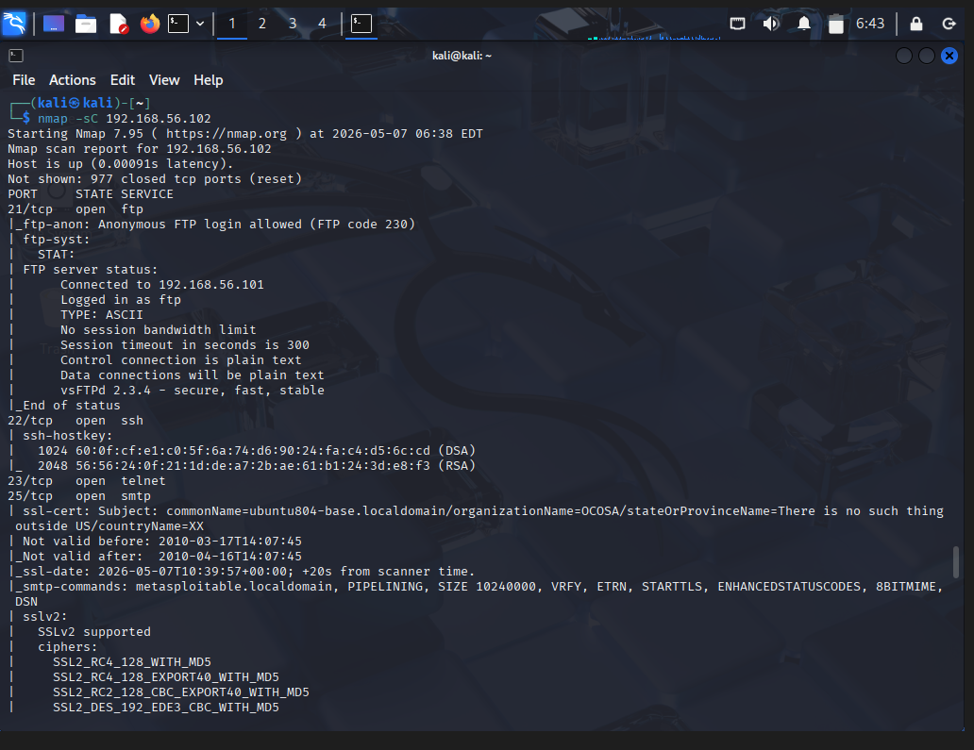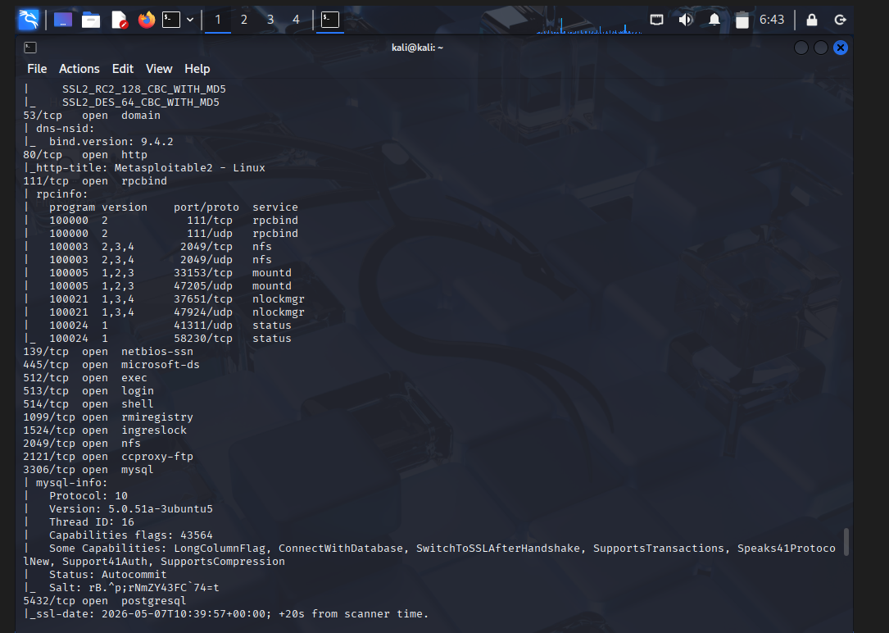
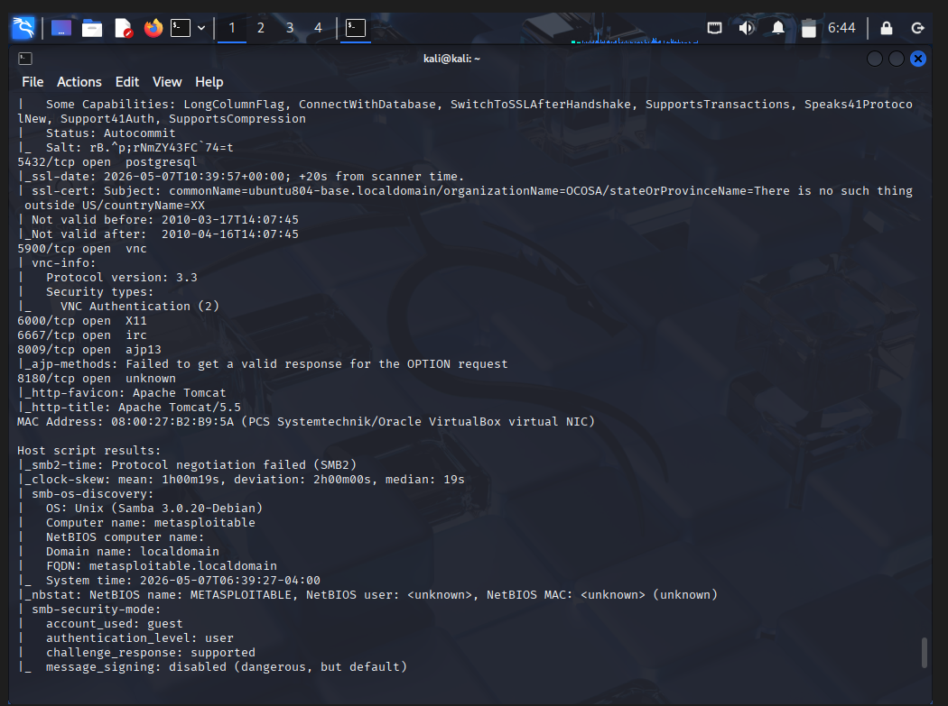

Moving on with the Nikto
A web server vulnerability scanner. It specifically analyzes web servers, HTTP services, web misconfigurations, dangerous files, outdated components.
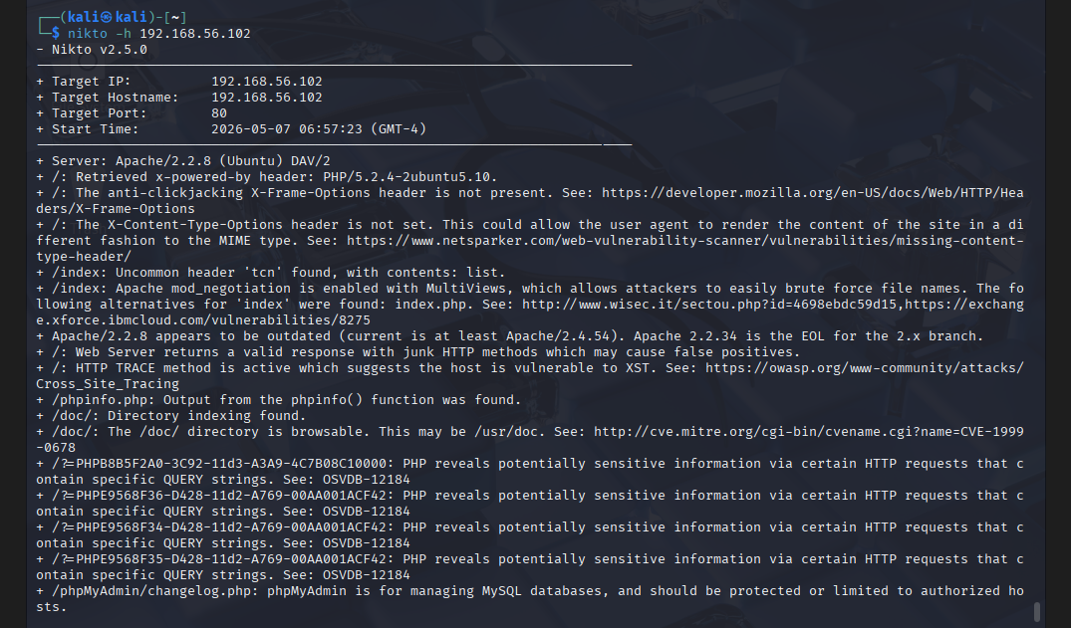

Nikto vulnerability scanning identified several web application and web server security weaknesses on the Apache HTTP service running on port 80. The scan revealed missing security headers such as X-Frame-Options and X-Content-Type-Options, which may expose users to attacks like clickjacking and MIME-type confusion. These missing headers indicate improper HTTP hardening configurations.
Nikto also identified that the Apache server version 2.2.8 was outdated and no longer supported. End-of-life software versions are dangerous because they no longer receive security patches from vendors, making them highly susceptible to publicly known exploits. The scan further detected that the HTTP TRACE method was enabled, which may expose the server to Cross-Site Tracing attacks.
Directory indexing vulnerabilities were also discovered, allowing attackers to browse sensitive directories exposed on the web server. Additionally, files such as phpinfo.php and phpMyAdmin pages were accessible, potentially leaking sensitive system and configuration information. Such information disclosure vulnerabilities can help attackers gather intelligence before launching advanced attacks.
The identified vulnerabilities collectively demonstrate a weak security posture of the target system. Exposure of outdated services, insecure protocols, and weak web server configurations significantly increases the possibility of unauthorized access, remote exploitation, privilege escalation, and information disclosure.
Services like Telnet and FTP transmit information without encryption, making them vulnerable to credential interception attacks. SMB misconfigurations may allow attackers to exploit authentication weaknesses or conduct lateral movement within networks. Outdated web technologies such as Apache 2.2.8 and Tomcat 5.5 are particularly dangerous because many public exploits are readily available for these versions.
If exploited successfully, attackers could:
- gain remote shell access,
- steal sensitive data,
- compromise databases,
- perform denial-of-service attacks,
- or establish persistent access within the environment.
The combination of outdated software and exposed services demonstrates inadequate patch management and poor security hardening, both of which are common causes of real-world compromises.
The explanation of the vulnerabilities found from the Nikto are as follows

  - Missing X-Frame-Options Header
Nikto detected that the X-Frame-Options security header is missing from the web server responses. This header is used to prevent the website from being embedded inside frames or iframes on malicious websites. Without this protection, attackers can perform clickjacking attacks by tricking users into interacting with hidden or disguised web elements.

Security Impact
The absence of the X-Frame-Options header may allow attackers to create malicious pages that overlay or hide the legitimate website interface. Users may unknowingly click sensitive buttons, submit forms, or reveal credentials while believing they are interacting with a legitimate webpage. This can lead to unauthorized transactions, credential theft, and manipulation of user actions.

  - Missing X-Content-Type-Options Header
The Nikto scan revealed that the X-Content-Type-Options header is not configured on the web server. This security header helps prevent browsers from MIME-sniffing a response away from the declared content type. Without this protection, browsers may incorrectly interpret certain files and execute malicious content.

Security Impact
An attacker may exploit MIME-sniffing behavior to disguise malicious scripts or executable content as harmless files. This could result in the execution of unintended scripts within the user’s browser, leading to cross-site scripting attacks, session hijacking, or content spoofing. Proper content-type validation is essential to reduce such risks.

  - HTTP TRACE Method Enabled
Nikto identified that the HTTP TRACE method is enabled on the target web server. TRACE is an HTTP diagnostic method used to echo received requests back to the client. Although originally intended for debugging purposes, it is considered insecure in production environments.

Security Impact
The TRACE method can be exploited through Cross-Site Tracing (XST) attacks, allowing attackers to capture sensitive request headers such as authentication tokens and cookies. In certain cases, attackers may bypass client-side protections and obtain confidential session information, increasing the risk of session hijacking and unauthorized access.

  - Directory Indexing Enabled
The scan revealed that several directories such as /doc/, /icons/, and /test/ allow directory indexing. Directory indexing occurs when the server displays the contents of a directory instead of denying access or serving a default page. This exposes the internal structure of the web application to users and attackers.

Security Impact
Exposed directories may allow attackers to browse files, identify backup data, locate test applications, discover sensitive documents, or analyze the internal architecture of the web server. Information obtained through directory indexing can assist attackers during reconnaissance and increase the likelihood of successful exploitation attempts.

  - phpinfo.php File Exposed
Nikto detected the presence of a publicly accessible phpinfo.php file on the target server. The phpinfo function is commonly used by developers for debugging and displays detailed information about the PHP environment and server configuration.

Security Impact
The exposed phpinfo page may reveal highly sensitive information including PHP version details, enabled modules, server paths, operating system information, environment variables, and configuration settings. This information provides attackers with valuable intelligence that can be used to identify vulnerabilities and craft more precise attacks against the target system.

  - Exposed phpMyAdmin Interface
The Nikto scan identified the presence of phpMyAdmin files and directories on the server. phpMyAdmin is a web-based MySQL database administration tool commonly used to manage databases through a browser interface.

Security Impact
If the phpMyAdmin interface is not properly secured, attackers may attempt brute-force attacks, exploit known vulnerabilities, or gain unauthorized access to the database management system. Successful compromise could allow attackers to read, modify, or delete database contents, resulting in severe data breaches and loss of integrity.

  - Sensitive WordPress Configuration File Found
Nikto discovered a file named #wp-config.php#, which appears to be a backup or temporary copy of the WordPress configuration file. Such files may accidentally remain accessible on production servers after editing or backup operations.

Security Impact
The WordPress configuration file often contains critical information including database usernames, passwords, authentication salts, and server configuration details. Exposure of this file may allow attackers to gain database access, compromise the web application, and escalate attacks against the entire server environment. This finding represents a critical security risk.

  - PHP Information Disclosure Through Query Strings
Nikto reported that certain PHP requests may reveal sensitive information when specific query strings are supplied. This indicates improper handling of error messages or debugging information within the application.

Security Impact
Improperly handled PHP responses may disclose application structure, backend logic, file paths, or debugging details that should remain hidden from users. Attackers can use this information to better understand the application architecture, identify vulnerable components, and develop targeted exploitation techniques.

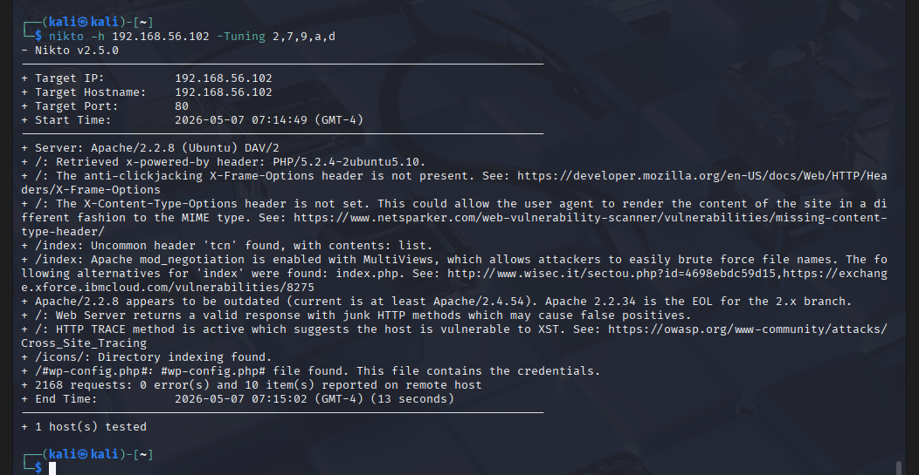

Misconfiguration Testing (-Tuning 2)
The -Tuning 2 option in Nikto focuses on identifying web server misconfigurations and insecure settings. During this scan, Nikto detected several security weaknesses including missing security headers such as X-Frame-Options and X-Content-Type-Options, enabled HTTP TRACE method, and accessible directory indexing. These findings indicate that the web server has not been properly hardened against common web-based attacks. Misconfigurations such as these may expose the server to clickjacking attacks, MIME-sniffing vulnerabilities, information disclosure, and Cross-Site Tracing attacks. Proper security header implementation and disabling unnecessary HTTP methods are important defensive measures that were absent on the target system.

Security Impact
Improper web server configurations increase the overall attack surface of the application. Missing security headers may allow attackers to manipulate browser behavior, while enabled TRACE functionality can expose sensitive session information. Directory indexing additionally allows attackers to browse internal server directories and discover sensitive files or application structures. Together, these weaknesses make the target system more vulnerable to reconnaissance, information gathering, and further exploitation attempts.

Remote File Retrieval Testing (-Tuning 7)
The -Tuning 7 option performs checks related to remote file retrieval and exposed sensitive resources. During this assessment, Nikto identified the presence of a potentially dangerous file named #wp-config.php#, which appears to be a backup or temporary copy of a WordPress configuration file. Such files are often unintentionally left accessible on production servers after editing or backup operations. The scan also identified several exposed directories and accessible configuration-related resources that should normally be restricted from public access.

Security Impact
Exposed configuration files represent a severe security risk because they may contain highly sensitive information such as database usernames, passwords, authentication salts, and application secrets. If attackers gain access to these files, they may be able to compromise backend databases, obtain administrative access, or fully compromise the web application environment. Information disclosure through exposed files also significantly assists attackers during the reconnaissance and attack planning phases.

SQL Injection Related Checks (-Tuning 9)
The -Tuning 9 option in Nikto focuses on identifying indicators associated with SQL injection and database-related weaknesses. During the scan, Nikto identified references to phpMyAdmin components and detected PHP behaviors that may reveal sensitive information through specially crafted requests. While the scan did not explicitly confirm a successful SQL injection vulnerability, it identified several indicators suggesting that the web application may not be securely handling database-related operations or sensitive backend interactions.

Security Impact
Database-related weaknesses are highly dangerous because attackers often target backend databases to access sensitive organizational data. Exposed database administration interfaces such as phpMyAdmin increase the risk of brute-force attacks, credential theft, and unauthorized database access. Additionally, improper handling of PHP requests may reveal debugging details or internal application behavior that could assist attackers in developing more advanced injection-based attacks against the target system.
Authentication Related Checks (-Tuning a)
The -Tuning a option performs checks related to authentication mechanisms, access controls, and protected resources. During the assessment, Nikto identified publicly accessible phpMyAdmin resources and administrative-related files that may not be adequately restricted. Administrative interfaces exposed to unauthenticated users increase the risk of unauthorized access attempts and indicate weak access control implementation on the target server.

Security Impact
Weak authentication controls can allow attackers to target exposed administrative interfaces using brute-force attacks, default credentials, or publicly known vulnerabilities. If authentication mechanisms are not properly secured, attackers may gain unauthorized administrative access to the web application or underlying databases. This could lead to data compromise, modification of server configurations, and escalation of privileges within the target environment.

Dangerous File and CGI Checks (-Tuning d)
The -Tuning d option focuses on identifying dangerous files, insecure CGI scripts, debugging resources, and test applications. During the scan, Nikto discovered publicly accessible resources including phpinfo.php, /test/ directories, and several exposed documentation-related files. The presence of these resources indicates poor web server maintenance and inadequate restriction of development or testing files in the production environment.

Security Impact
Dangerous files and debugging resources often reveal critical system information including software versions, server paths, enabled modules, PHP configurations, and internal application details. Attackers can use this information to better understand the target environment and identify vulnerable components for further exploitation. Exposed test directories and development files may additionally contain insecure scripts or weak configurations that can be directly abused during an attack.

Exploitation
After analyzing some of the vulnerabilities in the metasploitable 2 I tried to exploit some of the vulnerabilities by the help of Metasploit framework.

The first vulnerability is unreal_ircd which is basically used for the remote control.
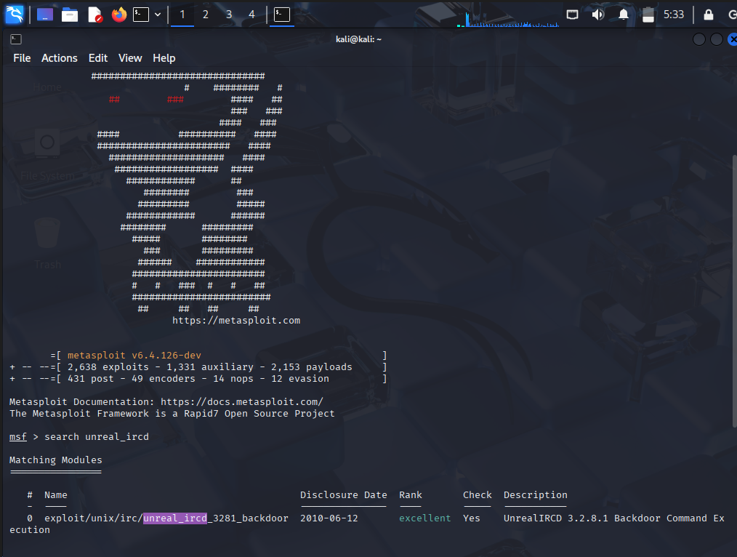
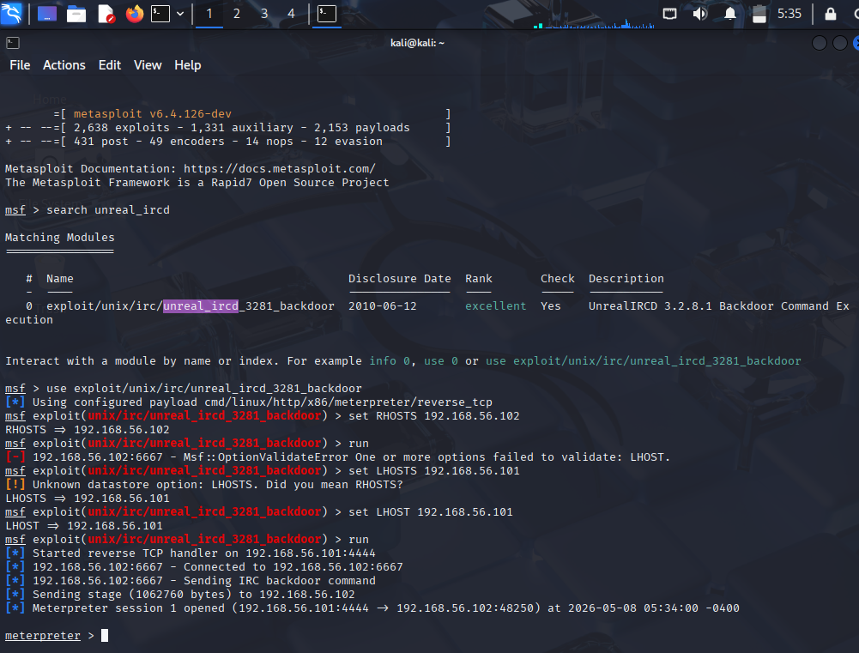

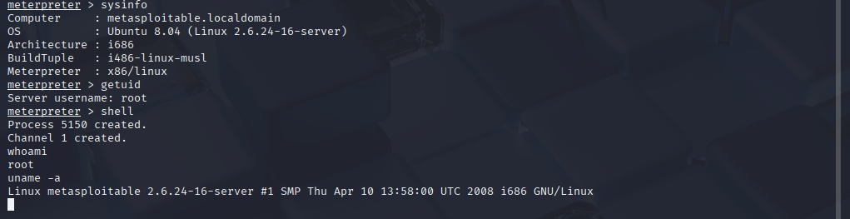

This shows that by the help of exploit I was able to get the access of the machine where I was able to show the system information and even was able to gain the admin access to the system.
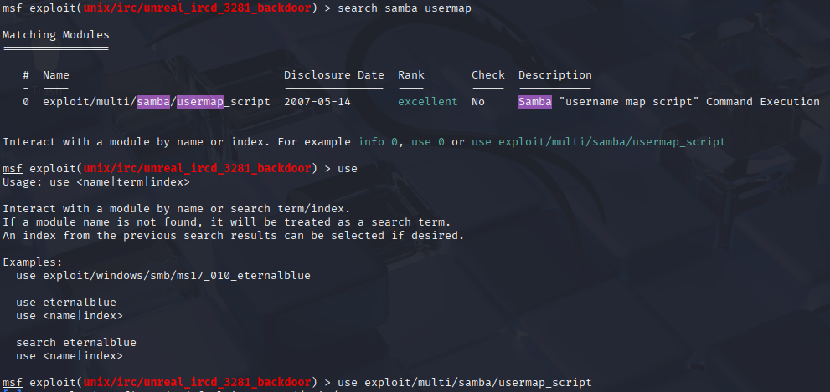

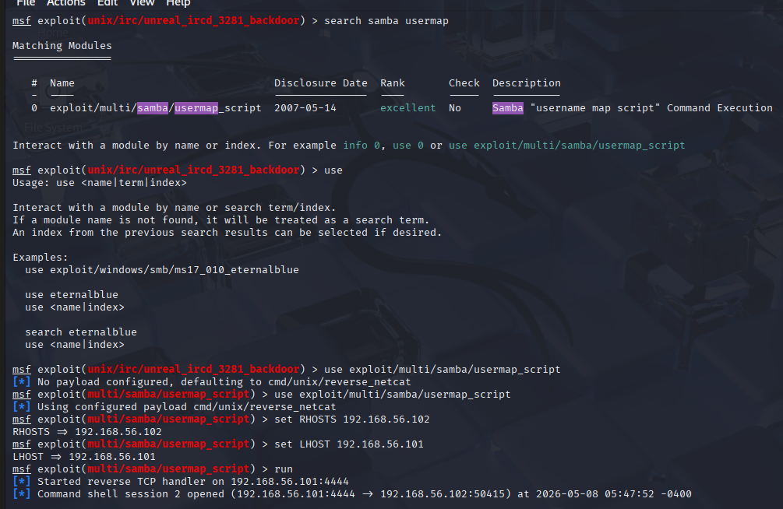

OpenVAS
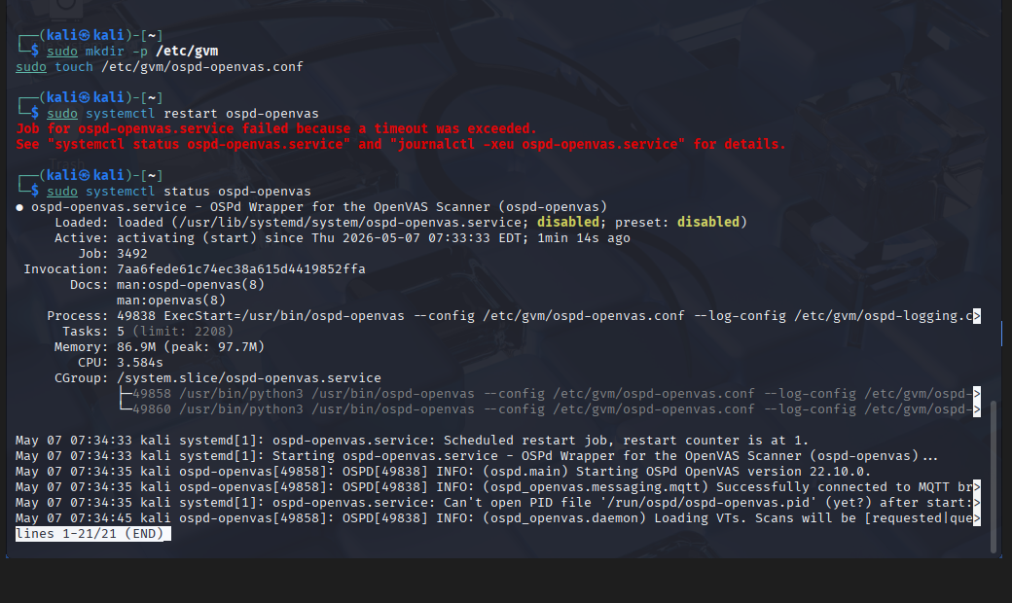
During the vulnerability assessment phase, OpenVAS (Greenbone Vulnerability Manager) was configured in the Kali Linux environment to perform automated vulnerability assessment activities. Initial setup issues related to Redis services, OSPD-OpenVAS daemon activation, and GVM service timeouts were encountered and resolved through manual service configuration and troubleshooting steps. This process helped ensure the scanner environment was properly initialized before conducting assessment activities.

OpenVAS Vulnerability Scanner Configuration
The OpenVAS (Greenbone Vulnerability Management) framework was installed and configured within the Kali Linux environment to perform automated vulnerability scanning. The setup process involved:
- Redis server configuration,
- certificate generation,
- GVM service initialization,
- feed synchronization,
- and vulnerability scanner deployment.
During initialization, several service timeout and daemon startup issues were encountered while configuring ospd-openvas and gvmd. Troubleshooting steps included:
- restarting services,
- increasing virtual machine resources,
- validating Redis functionality,
- generating certificates,
- and manually checking daemon status.
Although complete scanner execution experienced service timeout limitations, the configuration process provided practical exposure to enterprise vulnerability management infrastructure and security tool troubleshooting methodologies.

Risk assessment
Risk assessment was performed using a qualitative ISO 27001-aligned risk matrix methodology based on likelihood and impact analysis. Each identified vulnerability was evaluated according to the probability of successful exploitation and the potential impact on confidentiality, integrity, and availability of the target system. Risks were categorized into Low, Medium, High, and Critical severity levels to support remediation prioritization and security decision-making.

Likelihood Scale
Rating | Value | Meaning
Low | 1 | Exploitation unlikely or difficult
Medium | 2 | Exploitation possible with moderate effort
High | 3 | Exploitation easy or publicly available

Impact Scale
Rating | Value | Meaning
Low | 1 | Minimal operational or security impact
Medium | 2 | Moderate impact on confidentiality, integrity, or availability
High | 3 | Severe compromise, unauthorized access, or major system impact
Risk Score |  | Severity
1–2 |  | Low
3–4 |  | Medium
6 |  | High
9 |  | Critical

Findings- Documentation
Proper documentation ensures that the assessment is understandable, reproducible, and useful for remediation teams. During this phase, all outputs generated from tools such as Nmap, Nikto, and OpenVAS are organized into structured findings. The documentation phase transforms raw scan results into meaningful security insights.
the vulnerable machine Metasploitable2 was scanned using multiple open-source tools to identify exposed services, outdated software, insecure configurations, and weak protocols. Each discovered issue should be documented with technical details such as IP address, port number, service version, vulnerability description, severity level, affected technology, and recommended remediation.
IP Address | Port | Service | Vulnerability | Severity | Tool Used | Recommended Fix
192.168.56.102 | 21 | FTP | Anonymous FTP login enabled | High | Nmap | Disable anonymous access
192.168.56.102 | 22 | SSH | Outdated OpenSSH version | Medium | Nmap | Upgrade OpenSSH
192.168.56.102 | 80 | Apache HTTP | Outdated Apache 2.2.8 server | High | Nikto | Patch Apache server
192.168.56.102 | 80 | HTTP | HTTP TRACE method enabled | Medium | Nikto | Disable TRACE method
192.168.56.102 | 139/445 | SMB | SMB signing disabled | High | Nmap | Enable SMB signing
192.168.56.102 | 8180 | Apache Tomcat | Outdated Tomcat 5.5 detected | High | Nmap | Upgrade Tomcat
192.168.56.102 | 3306 | MySQL | Old MySQL version exposed | Medium | Nmap | Restrict DB exposure
192.168.56.102 | 5900 | VNC | Remote desktop service exposed | Medium | Nmap | Restrict VNC access
192.168.56.102 | 6667 | IRC | UnrealIRCd service exposed | High | Nmap | Update/remove vulnerable IRC service

During enumeration, multiple services were identified running on the Metasploitable2 target system. These services significantly increased the attack surface of the machine because several outdated and insecure applications were publicly exposed over the network. Service enumeration performed through Nmap revealed insecure protocols such as FTP, Telnet, SMB, and VNC, which are commonly targeted by attackers during penetration testing and real-world cyberattacks.
The scan also revealed several outdated software versions including Apache HTTP Server 2.2.8, MySQL 5.0.51a, Samba 3.0.20, and Apache Tomcat 5.5. Older software versions are highly risky because they may contain publicly known vulnerabilities associated with CVEs and exploit modules. Attackers frequently target such outdated services to gain unauthorized access, perform privilege escalation, or exfiltrate sensitive information.
The exposure of multiple services on unnecessary ports also demonstrated poor security hardening practices. Open services increase the likelihood of exploitation because every accessible port potentially introduces a new attack vector.

Finding IPT-001: Anonymous FTP Enabled
The assessment identified that the FTP service running on the Metasploitable2 target system permitted anonymous authentication without requiring valid user credentials. This means that any user connected to the network could access the FTP server without authorization. Anonymous FTP access is considered a major security weakness because attackers can use it to browse directories, download sensitive files, or potentially upload malicious content to the server.
The vulnerability was identified during the Nmap service enumeration phase, where the FTP service responded positively to anonymous login attempts. The presence of unauthenticated access demonstrates weak access control implementation and poor service hardening practices.

Security Impact
Anonymous FTP access significantly increases the attack surface of the target system. Attackers may use the service for information gathering, unauthorized data access, malware distribution, or further exploitation attempts. If write permissions are enabled, attackers may upload malicious files, backdoors, or web shells that could lead to full system compromise.
Additionally, exposed FTP services are commonly targeted during penetration testing and real-world cyberattacks because they are easy to discover using automated scanning tools. The lack of authentication also violates basic security principles related to confidentiality and access control.

Mitigation Strategies
Anonymous FTP access should be disabled unless explicitly required for business purposes. Authentication should be enforced for all FTP users, and strong password policies should be implemented to protect user accounts. Organizations should also restrict FTP access using firewall rules and network segmentation to limit exposure to trusted systems only.
Where possible, insecure FTP services should be replaced with secure alternatives such as SFTP or FTPS, which provide encrypted communication and stronger authentication mechanisms. Regular service audits and vulnerability scans should also be conducted to identify insecure configurations before deployment into production environments.

Finding IPT-002: Telnet Service Enabled
The Telnet service was identified running on the target system during network enumeration activities. Telnet is considered an insecure remote administration protocol because it transmits usernames, passwords, and session data in plaintext across the network. Any attacker capable of intercepting network traffic may capture sensitive credentials directly from Telnet communications.
The service was discovered through Nmap scanning, which identified port 23/tcp as open and actively running the Telnet protocol. The presence of Telnet demonstrates outdated and insecure remote access practices within the target environment.

Security Impact
Telnet poses a serious security risk because attackers performing network sniffing or man-in-the-middle attacks can easily capture authentication credentials and session information. Once credentials are obtained, attackers may gain unauthorized access to the system and perform malicious activities such as privilege escalation, data theft, or service disruption.
Because Telnet lacks encryption, all transmitted information remains visible to attackers monitoring the network. The use of legacy protocols such as Telnet also indicates insufficient security hardening and weak protocol management practices.

Mitigation Strategies
The Telnet service should be disabled immediately and replaced with secure alternatives such as SSH (Secure Shell), which provides encrypted remote communication and stronger authentication mechanisms. Organizations should enforce secure remote administration standards and remove all legacy protocols that transmit information in plaintext.
Firewall restrictions should also be implemented to limit remote administrative access only to authorized systems and administrators. Periodic service audits and protocol reviews should be conducted to identify insecure services and ensure compliance with modern security standards.

Finding IPT-003: Outdated Apache HTTP Server
The Nikto vulnerability scan identified that the target web server was running Apache HTTP Server version 2.2.8, which is an outdated and unsupported version of Apache. End-of-life software versions no longer receive security updates or vendor patches, making them highly vulnerable to publicly known exploits and remote attacks.
Outdated web server software significantly increases the likelihood of exploitation because attackers can use publicly available exploit databases and vulnerability frameworks to target known weaknesses associated with older Apache versions.

Security Impact
An outdated Apache server may allow attackers to exploit vulnerabilities that lead to remote code execution, denial-of-service attacks, directory traversal, information disclosure, or unauthorized access to hosted web applications. Since older versions lack modern security protections and patches, attackers can compromise the server more easily compared to updated environments.
Compromise of a web server can also provide attackers with access to sensitive web application data, configuration files, or backend systems connected to the server. Web servers are often high-value targets because they are publicly accessible and commonly exposed to network traffic.

Mitigation Strategies
The Apache HTTP Server should be upgraded to the latest stable and supported version immediately. Regular patch management procedures should be implemented to ensure all software components receive timely security updates and vendor patches.
Organizations should also implement vulnerability management processes that include:
- periodic patch verification,
- automated vulnerability scanning,
- software inventory management,
- and continuous monitoring of publicly exposed services.
Removing unnecessary modules and enforcing secure web server configurations can further reduce the attack surface of the environment.

Finding IPT-004: SMB Signing Disabled
The assessment identified that SMB signing was disabled on the target system. SMB signing is a security mechanism used to verify the integrity and authenticity of SMB network communications. When SMB signing is disabled, attackers may perform SMB relay or man-in-the-middle attacks by intercepting and modifying network traffic between systems.
This vulnerability was identified during SMB enumeration activities using Nmap scripts and service analysis. The absence of SMB signing indicates weak network hardening practices and insufficient protection of internal communications.

Security Impact
Disabled SMB signing may allow attackers to intercept authentication requests and relay them to other systems without requiring valid user credentials. Successful SMB relay attacks may result in unauthorized access, privilege escalation, lateral movement across the network, or remote code execution.
Because SMB is commonly used within enterprise networks for file sharing and administrative communication, exploitation of SMB weaknesses can significantly impact internal network security and facilitate broader compromise of connected systems.

Mitigation Strategies
SMB signing should be enabled on all systems to ensure the integrity and authenticity of SMB communications. Organizations should additionally disable outdated SMB versions such as SMBv1 and implement network segmentation to reduce the risk of lateral movement attacks.
Security administrators should regularly review SMB configurations, monitor suspicious authentication activity, and restrict unnecessary SMB exposure across networks. Applying modern security baselines and hardening standards can further reduce SMB-related attack risks.

Finding IPT-005: Exposed Apache Tomcat Service
The assessment identified an exposed Apache Tomcat service running on the target system. Apache Tomcat is a web application server commonly used to host Java-based applications. The detected Tomcat version appeared outdated and publicly accessible over the network, increasing the risk of exploitation through known vulnerabilities or weak administrative configurations.
Publicly exposed application servers often become targets for attackers because they may contain insecure default configurations, weak credentials, outdated software, or vulnerable management interfaces.

Security Impact
An exposed and outdated Tomcat server may allow attackers to exploit vulnerabilities leading to remote code execution, unauthorized application deployment, privilege escalation, or compromise of hosted web applications. If administrative interfaces are exposed, attackers may attempt brute-force attacks or leverage default credentials to gain control of the server.
Compromise of the Tomcat environment may also provide attackers with access to sensitive application data, backend systems, or internal network resources connected to the server.

Mitigation Strategies
The Apache Tomcat service should be updated to the latest supported version, and all unnecessary administrative interfaces should be disabled or restricted. Strong authentication controls should be implemented for management consoles, and default credentials must be changed immediately.
Access to Tomcat services should be restricted using firewall rules and network segmentation to minimize exposure to unauthorized users. Regular vulnerability scanning and patch management should also be conducted to identify and remediate newly discovered vulnerabilities.

Finding IPT-006: Exposed phpMyAdmin Interface
The Nikto assessment identified that the phpMyAdmin administrative interface was publicly accessible on the target web server. phpMyAdmin is a web-based database management application commonly used to administer MySQL databases. When exposed without proper access restrictions, it becomes a high-value target for attackers attempting to gain unauthorized access to backend databases.
Publicly accessible database administration panels increase security risks because attackers may attempt brute-force attacks, credential guessing, default credential usage, or exploitation of known phpMyAdmin vulnerabilities. The exposure of administrative interfaces also indicates insufficient web application hardening practices.

Security Impact
An exposed phpMyAdmin interface may allow attackers to gain unauthorized database access, extract sensitive information, modify database contents, or completely compromise backend systems. If successful, attackers could retrieve usernames, passwords, application data, or other confidential organizational information stored within the database environment.
Because databases often contain critical application information, successful exploitation may lead to data breaches, service disruption, unauthorized modifications, or further compromise of connected systems.

Mitigation Strategies
Access to phpMyAdmin should be restricted to authorized administrators only using firewall rules, IP whitelisting, VPN-based access, or authentication mechanisms. Public internet exposure of administrative interfaces should be avoided wherever possible.
Organizations should also:
- disable unused administrative tools,
- enforce strong passwords,
- implement multi-factor authentication,
- and regularly update phpMyAdmin to the latest secure version.
Security monitoring should additionally be enabled to detect unauthorized access attempts or suspicious authentication activity.

Finding IPT-007: Default Credentials on Services
The assessment identified services and applications that were potentially operating using default or weak credentials. Default credentials are widely known usernames and passwords provided by vendors during installation and are commonly targeted during automated attacks and penetration testing activities.
Attackers frequently use publicly available default credential databases to gain unauthorized access to systems, administrative panels, routers, databases, and web applications. The continued use of default credentials demonstrates weak password management and poor security configuration practices.

Security Impact
Systems operating with default credentials are highly vulnerable to unauthorized access because attackers can gain administrative control without requiring advanced exploitation techniques. Successful access may allow attackers to modify configurations, extract sensitive data, deploy malicious payloads, or establish persistent access to the environment.
Default credentials significantly increase the likelihood of compromise because automated tools commonly test these credentials during reconnaissance and brute-force attacks. Once compromised, attackers may further exploit the environment through privilege escalation or lateral movement.

Mitigation Strategies
All default credentials should be changed immediately following installation or deployment of any service or application. Organizations should enforce strong password policies that include:
- password complexity,
- password rotation,
- account lockout controls,
- and unique administrative credentials.
Multi-factor authentication should also be implemented for critical administrative services wherever possible. Regular security audits should be conducted to identify weak or default credentials before systems are exposed to production environments.

Finding IPT-008: Weak Web Server Security Headers
The Nikto web vulnerability assessment identified missing or improperly configured HTTP security headers on the Apache web server. Important security headers such as X-Frame-Options, X-Content-Type-Options, and related browser security protections were absent from server responses.
Security headers play a critical role in protecting web applications against browser-based attacks including clickjacking, MIME-type confusion attacks, and certain forms of content injection. Missing security headers indicate insufficient web application hardening and weak secure configuration management practices.

Security Impact
Improperly configured security headers may expose users and applications to multiple client-side attack vectors. Attackers may exploit these weaknesses to manipulate browser behavior, trick users into interacting with malicious content, or bypass browser security protections.
Although missing security headers may not directly lead to full system compromise, they significantly weaken overall application security posture and increase the effectiveness of other web-based attacks.

Mitigation Strategies
Organizations should implement secure HTTP response headers according to modern web security best practices. Recommended headers should include:
- X-Frame-Options,
- X-Content-Type-Options,
- Content-Security-Policy,
- and Strict-Transport-Security.
Web servers and applications should also undergo regular security hardening reviews and vulnerability assessments to identify insecure configurations. Security baselines and configuration standards should be enforced across all web applications and server deployments.

Finding IPT-009: Weak Patch Management Practices
The assessment identified multiple outdated services, legacy applications, and unsupported software components within the target environment. These findings indicate weak patch management and insufficient software maintenance practices across the system.
Several services detected during enumeration and vulnerability scanning were running older versions containing publicly known vulnerabilities and security weaknesses. Poor patch management significantly increases organizational exposure to exploitation because attackers commonly target outdated systems using publicly available exploits.

Security Impact
Weak patch management practices increase the risk of remote code execution, privilege escalation, information disclosure, and denial-of-service attacks. Attackers often prioritize outdated systems because exploit code for older vulnerabilities is widely available and easy to use.
Failure to apply timely security updates may allow attackers to compromise critical services, gain unauthorized access, and maintain persistence within the environment. Outdated systems may additionally fail to comply with modern security standards and best practices.

Mitigation Strategies
Organizations should implement a formal patch management program to ensure all systems, services, and applications receive timely security updates. Patch management processes should include:
- vulnerability identification,
- update testing,
- scheduled deployment,
- and post-deployment verification.
Automated vulnerability scanning and asset inventory management should also be used to identify outdated software components continuously. Unsupported and end-of-life systems should be upgraded or removed from the environment wherever possible.

Recommendations
Based on the findings identified during the Vulnerability Assessment and Penetration Testing (VAPT) assessment, several security improvements are recommended to strengthen the overall security posture of the environment. The assessment revealed multiple insecure services, outdated software components, weak authentication mechanisms, and misconfigured network services that could potentially allow unauthorized access and system compromise.
One of the primary recommendations is to disable insecure and unnecessary services such as Telnet and anonymous FTP access. Legacy protocols that transmit data in plaintext should be replaced with secure alternatives such as SSH and SFTP to ensure encrypted communication and stronger authentication mechanisms. Removing unnecessary services also helps reduce the overall attack surface of the system.
The assessment additionally identified several outdated and unsupported software components, including Apache HTTP Server, Samba services, and UnrealIRCd. Organizations should implement a formal patch management process to ensure operating systems, applications, and network services receive regular security updates and vendor patches. Unsupported or end-of-life software should be upgraded or removed immediately to minimize exposure to publicly known vulnerabilities.
Administrative interfaces such as phpMyAdmin and Apache Tomcat management services should be restricted to authorized users only through firewall rules, network segmentation, and strong authentication mechanisms. Default credentials must be changed immediately, and strong password policies should be enforced across all services and applications.
Network security controls should also be improved by enabling SMB signing, disabling outdated protocols such as SMBv1, and restricting unnecessary exposure of internal services. Firewall rules and access control policies should be configured to limit access to sensitive services only to trusted systems and authorized administrators.
To improve long-term security management, organizations should conduct periodic vulnerability assessments and penetration testing activities to identify newly introduced vulnerabilities and configuration weaknesses. Continuous security monitoring, log analysis, and intrusion detection mechanisms should additionally be implemented to detect suspicious activities and unauthorized access attempts.
Finally, organizations should establish secure configuration baselines and security hardening standards for servers, applications, and network services. Security awareness and administrative best practices should also be promoted to reduce the likelihood of insecure deployments and weak configuration management practices.

Conclusion
The identified vulnerabilities demonstrated weak system hardening, insecure authentication mechanisms, and poor security configuration management. The exploitation phase further validated the severity of several vulnerabilities through controlled exploitation using the Metasploit Framework. Successful exploitation of the UnrealIRCd backdoor vulnerability and Samba Username Map Script vulnerability demonstrated how attackers could potentially gain unauthorized remote access and execute commands on vulnerable systems.
A qualitative ISO 27001-aligned risk assessment methodology was used to evaluate the likelihood and impact of identified vulnerabilities. The assessment highlighted the importance of regular patch management, secure configuration practices, vulnerability scanning, and continuous monitoring to reduce organizational security risks.
The assessment also provided practical experience in configuring and troubleshooting vulnerability management tools such as OpenVAS, further enhancing understanding of enterprise security assessment infrastructure and real-world deployment challenges.
Overall, the assessment successfully achieved its objectives by identifying security weaknesses, validating exploitation risks, prioritizing vulnerabilities through risk assessment, and recommending remediation strategies to improve the overall security posture of the environment.

Challenges
OpenVAS Service Initialization Issues
During the configuration of OpenVAS/GVM, multiple service-related issues were encountered, including Redis server inactivity, OSPD-OpenVAS timeout errors, and GVM daemon startup failures. Troubleshooting involved validating Redis service status, generating GVM certificates, manually configuring OSPD services, and restarting related system services. These challenges highlighted the complexity of vulnerability scanner deployment and the importance of dependency management in security assessment environments.

